Project 9: Using Quadratic Equations to Model Situations and Solve Problems

Part 1: Equations of Two Lines and a Curve
Write an equation representing the line that passes through each pair of points.
- $(3,3)$ and $(5,5)$.
- $(0,4)$ and $(-4,0)$.
- Solve this equation: $x+1={\left(x-2\right)}^{2}-3$. Show your reasoning.

Part 2: Analyzing a Dive
The function $h$, defined by $h(t)={-5t}^{2}+10t+7.5$, models the height of a diver above the water (in meters) $t$ seconds after the diver leaves the board. For each question, explain your reasoning.
- How high above the water is the diving board?
- When does the diver hit the water?
- At what point during her descent toward the water is the diver at the same height as the diving board?
- When does the diver reach the maximum height of the dive?
- What is the maximum height the diver reaches during the dive?

Part 3: A Linear Function and a Quadratic Function
Here are the graphs of a linear function and a quadratic function. The quadratic function is defined by the expression ${\left(x-4\right)}^{2}-5$.
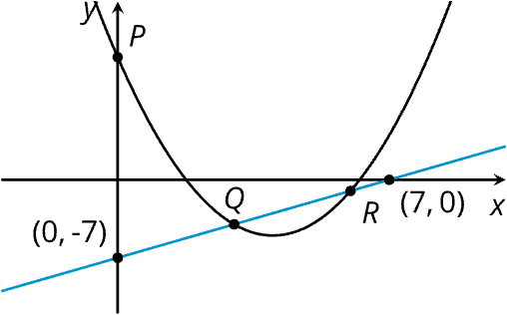
- Without using graphing technology, find the coordinates of $P$, $Q$, and $R$. Show your reasoning.

Part 4: Profit from a River Cruise
A travel company uses a quadratic function to model the profit, in dollars, that it expects to earn from selling tickets to a river cruise at 𝑑 dollars per person. The expression $-d^{2}+100d-900$ defines this function.
- Without graphing, find the price that would generate the maximum profit. Then, determine that maximum profit.

